Logger.java
public class Logger {
// Private static instance of the class
private static Logger instance;

// Private constructor to prevent instantiation from other classes
private Logger() {
// Initialize resources here if needed
}

// Public static method to get the single instance of the class
public static Logger getInstance() {
if (instance == null) {
synchronized (Logger.class) {
if (instance == null) {
instance = new Logger();
}
}
}
return instance;
}

// Example method for logging
public void log(String message) {
System.out.println("Log: " + message);
}
}

SingletonTest.java
public class SingletonTest {
public static void main(String[] args) {
// Get the single instance of Logger
Logger logger1 = Logger.getInstance();
Logger logger2 = Logger.getInstance();

System.out.println();

// Check if both references point to the same instance
if (logger1 == logger2) {
System.out.println("Logger instances are the same.");
} else {
System.out.println("Logger instances are different.");
}

// Test logging
logger1.log("This is a test log message.");
logger2.log("This is another test log message.");
}
}
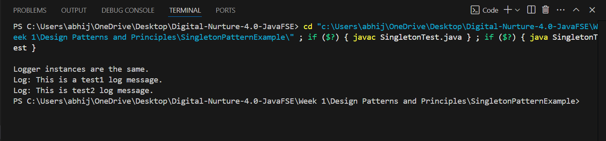
Output:

